Lesson Plan: How does a field of study in science connect with students’ everyday lives?

(this framework could be modified to explore subjects like geometry, ELA, etc.)

Purpose:
• To generate student conversations about the many different ways a single school subject can relate to common experiences and help students understand what characterizes a “field of inquiry” in terms of what is studied.
• To help students understand the kinds of questions that scientists ask in different branches of contemporary chemistry.

Note:
This sample activity is designed with the following NGSS (science) standards in mind—the activity will help contextualize later conversations about these standards throughout the year.

1. Structure and Function
The functions and properties of natural and designed objects and systems can be inferred from their overall structure, the way their components are shaped and used, and the molecular substructures of its various materials.
2. Stability and Change
Much of science deals with constructing explanations of how things change and how they remain stable.
3. Cause and Effect
Systems can be designed to cause a desired effect
4. Energy and Matter
Changes of energy and matter in a system can be described in terms of energy and matter flows into, out of, and within that system.

5. Scale, Proportion, and Quantity
Time, space, and energy phenomena can be observed at various scales using models to study systems that are too large or too small.

Materials needed:
You’ll notice in the PPT that we did not use the strict disciplinary sub-branches of chemistry like physical chemistry, organic chemistry, analytical chemistry, etc. These names mean little to students. We list instead broad areas of inquiry that have more understandable labels and that students could more readily link to their everyday lives.

PPT, doc camera, unused chemical ice-pack, cell phone, substance containing glycerin, markers of different colors, flip chart, large sticky notes (optional air filter, football or softball helmet).

Activity Structure
1. Framing:
• Spend 2 minutes framing why you are starting the year off with this lesson—why it is important to understand what a field of inquiry is and to understand the different kinds of questions that scientists ask.

2. Introduce:
• Use PowerPoint presentation to introduce the field and discuss the major topics that will be covered. Provide a short summary of each topic and ask students for additional examples that highlight each topic. (See notes in PPT)

3. Demo:
- Provide three phenomena that students will discuss with partners. Show videos, pictures, or demonstrate each phenomenon (in the sample PPT provided, we selected instant ice packs changing from warm to cold, lithium batteries losing power, and uses of glycerin as sweetener, solvent, or wetting agent in food).

4. Get in pairs:
- Allow ~8-10 minutes for student pairs to pick one phenomenon (of the three) and discuss which of the major topic(s) from the PPT would be helpful or necessary to explain how it works. Note: if students are with partners they haven’t worked with before, be sure to include opportunities for them to get to know each other. (For example, “With your new partner, exchange names and share what ice cream flavor is your favorite. Next, decide which phenomenon you would like to analyze, and discuss what topic(s) you think would help you explain it.”)
- Allow ~3 more minutes for each pair to find another pair that chose the same phenomenon. The new group of 4 will compare and discuss which area(s) of inquiry they believe may help explain their phenomenon and why. Providing sentence stems may be helpful to support discussion—we provide some at the end of this lesson plan.

5. Back to the whole class:
- Addressing the whole class, direct each group of 4 to send a representative to pick up a marker (all different colors) and draw lines on a flip chart between the phenomenon they chose and the topics they think it could connect to (see an example on p. 4). They should draw lines for their group, even if the connection was already made by another group (before class, you’ll need to draw the three phenomena in the center of a flip chart and the area of inquiry around the outside of the these).
  - Note: if your class contains more than 6 groups, it may be helpful to call on 2 or 3 groups to send their representative at a time.
• Ask the whole class if they observe any patterns, agreements, or disagreements with what lines were drawn on the flip chart. Ask for specific groups to share their thinking behind the connections they made (some students may recognize that some areas of inquiry are more fundamental than others, this is worth unpacking—“What do you mean?”).
  - For example, “It does look like the orange marker group connected lithium batteries to acids and bases, but the purple group did not. Would someone from the orange group be willing to share their reasoning?” or “Yes, many of the phenomena drew connections to the same topic of heat and energy. Why do you think that connection is so common?”
  - Note: if students are hesitant to initially share observations in whole class discussion, provide time for them to think/pair/share with their partner.
• If time permits, the teacher can present current research and investigations related to the subject and ask students what fields of inquiry experts might be helpful in solving the problem. (See PPT examples)
  - Note: if students are hesitant to initially share suggestions whole class discussion, provide time for them to think/pair/share with their partner.

6. Closure:
• (~3 minutes): Have each student, on a large sticky note, answer the following question: “In ten words or less, what experiences, problems, or questions have you had that could connect to the areas drawn on the white board?”
• Have students place their sticky note close to the area they think it would primarily relate to.
• Ask “What questions are we left with after these conversations?”

7. Quick analysis for formative assessment:
• Take a quick look at the sticky notes to see what students are interested in. Make planning notes for upcoming weeks to use some common examples the students brought up.
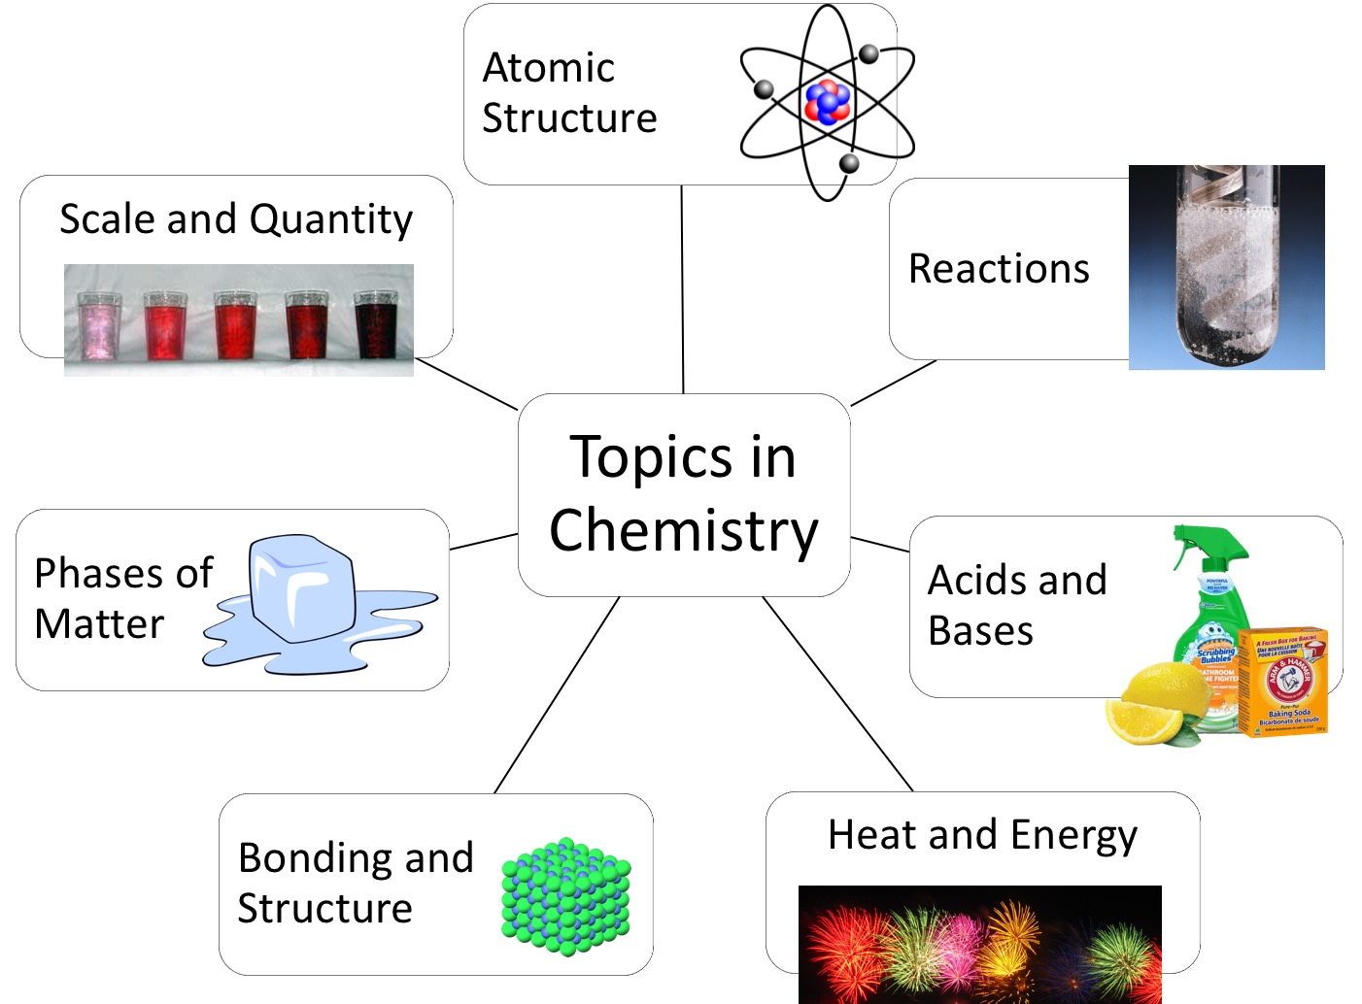
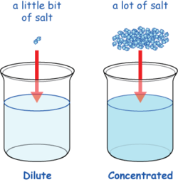
Heat and
Energy

Consider starting the next day with an entry task, asking students to deliberate with a partner which area of chemistry may be the most important for understanding events and processes in their everyday lives. The aim is to continually deepen students’ familiarity with what the field of chemistry studies and how different kinds of chemistry are needed to advance knowledge.

Sentence Stems:

It would be helpful to understand the topic of _________________ in order to explain phenomenon X because…

I think that phenomenon X relates to the topic of ________________ because…

Phenomenon X could also be related to the topic of ________________ because…

I think phenomenon X occurs/works because of ______________, which relates to the topic ________.

Sample flip chart before and after student contributions:

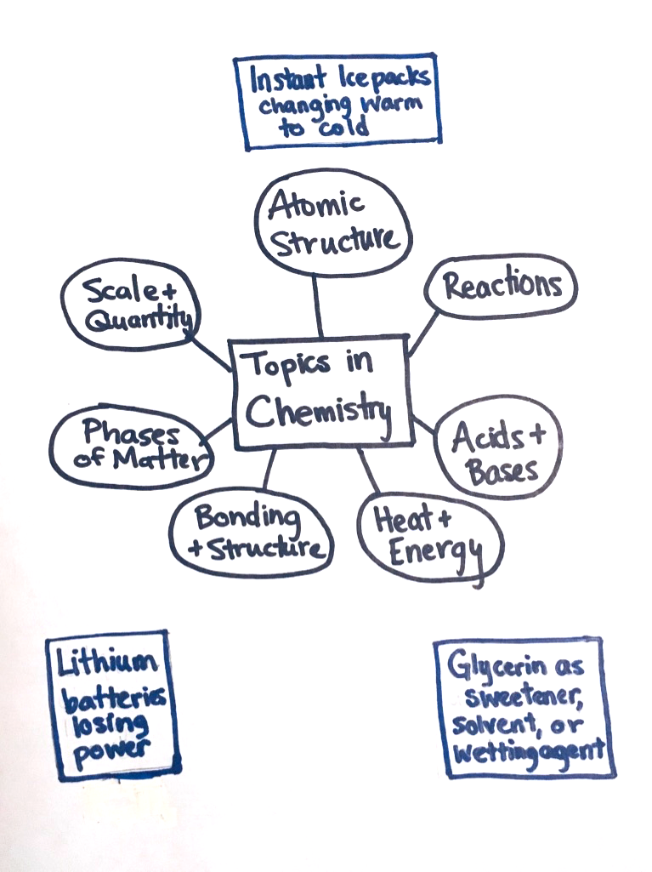
The topics are at the center, with the phenomena students could discuss around the outside.
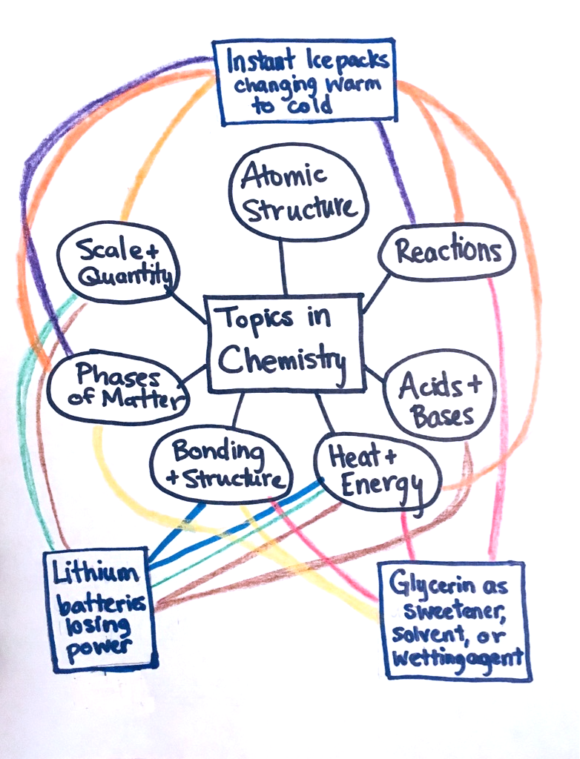
Each student group has its own color, and adds lines connecting the phenomenon they discussed to one or more topics. The lines represent which topics they think would be helpful or necessary for explaining how the phenomenon works.

